ETUDES NG JOB PREPARATION

A. Create Initial Course Title File:

District Information Technology will run a daily job (DF9996) to create basic course title file for all sections at your college. This file can be accessed from the LACCD PORTAL.

1. Using the LACCD Intranet, select the portal URL located at:

https://portal.laccd.edu/irj/portal
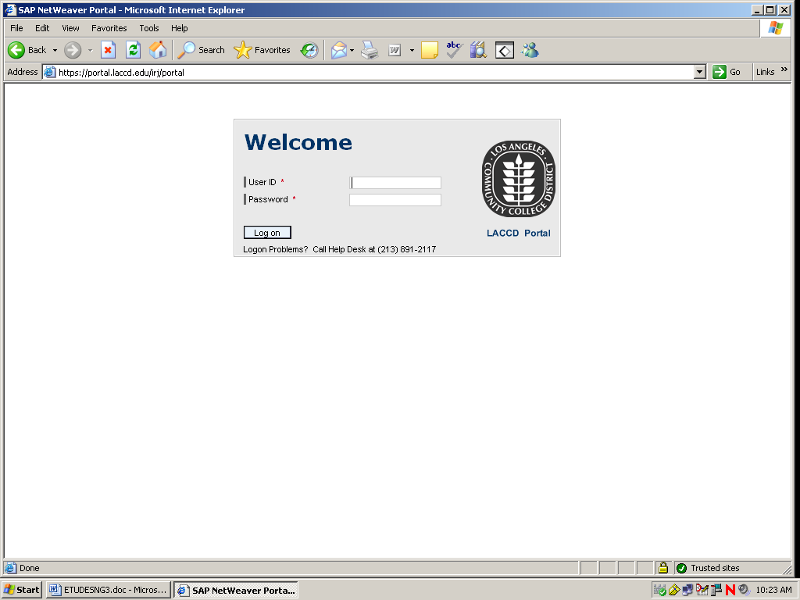

2. On the Welcome screen, logon using portal USERID and PASSWORD.
(If you do not know your PORTAL USERID and PASSWORD, then contact your College Network Administrator.)

3. Click on REPORTS
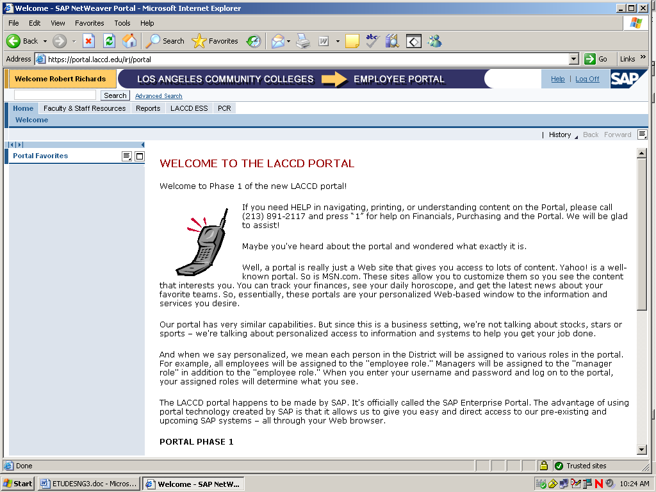

4. Click on FOCUS REPORTS.
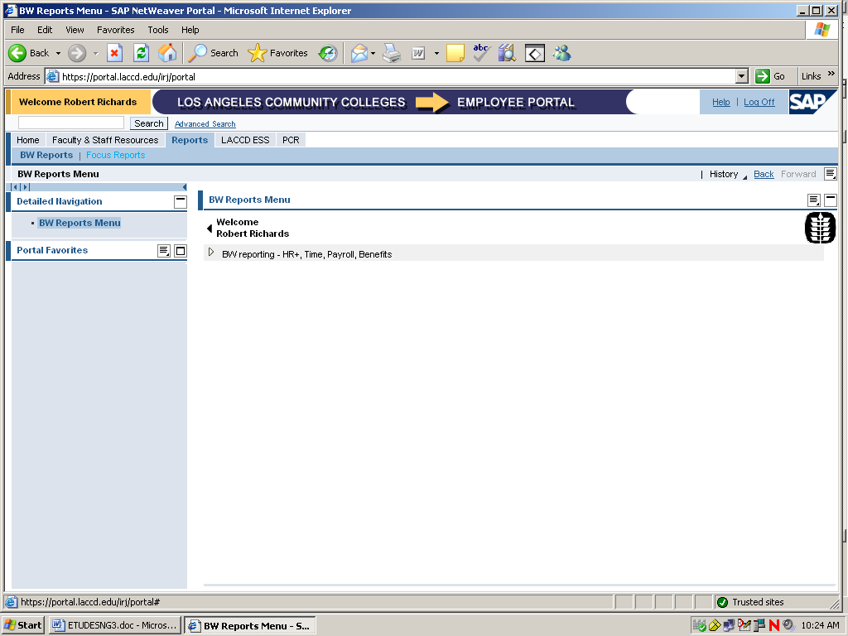

5. To continue, enter WEBFOCUS USERID and PASSWORD (different from PORTAL USERID)
(If you do not know your WEBFOCUS USERID and PASSWORD, then contact your College Network Administrator. He/she, in turn will contact Mike Javert of District I.T. email: JavertMK@email.laccd.edu
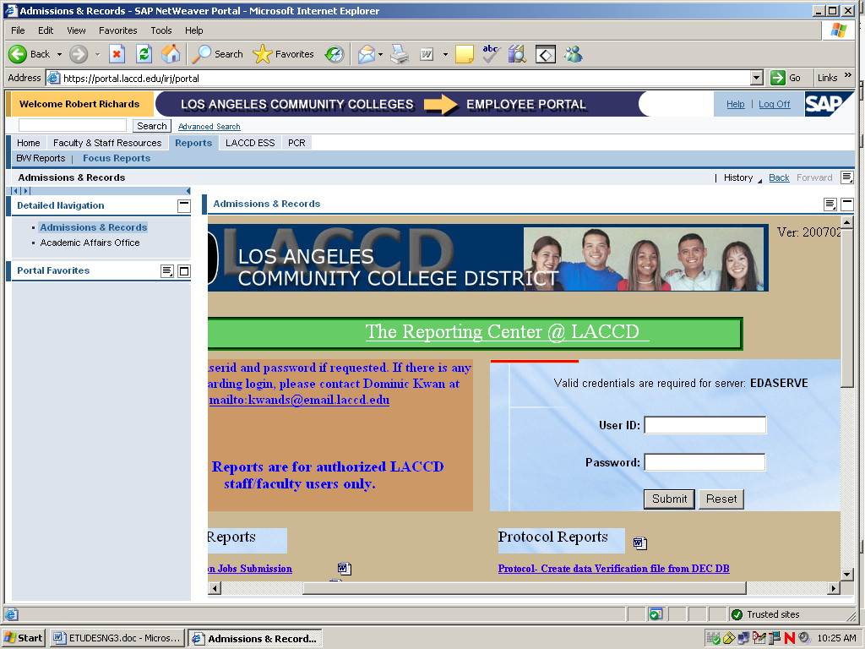
6. On reporting Center Screen go down to PRODUCTION REPORTS.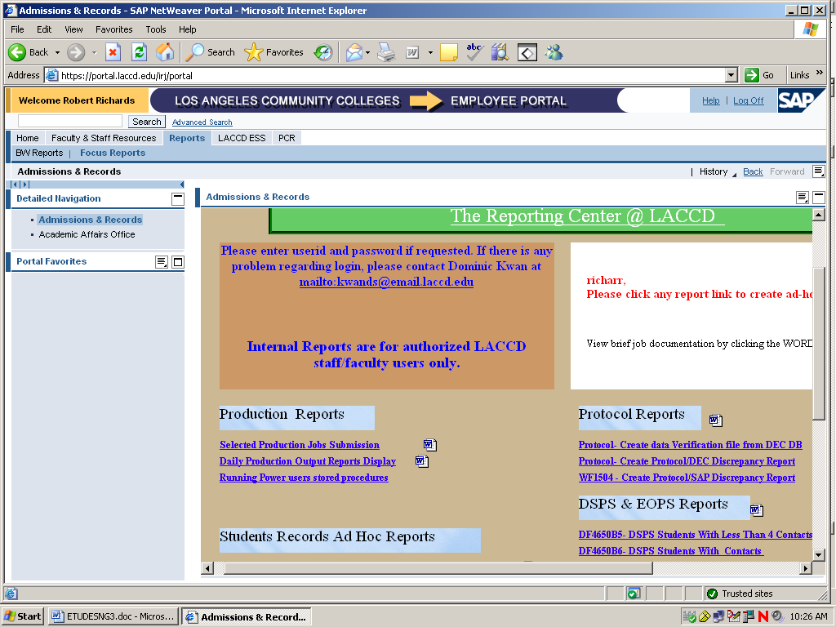

7. Click on Daily Production output reports Display.
8. On Admissions & Records Reports screen click/select:
Campus and then press submit button.
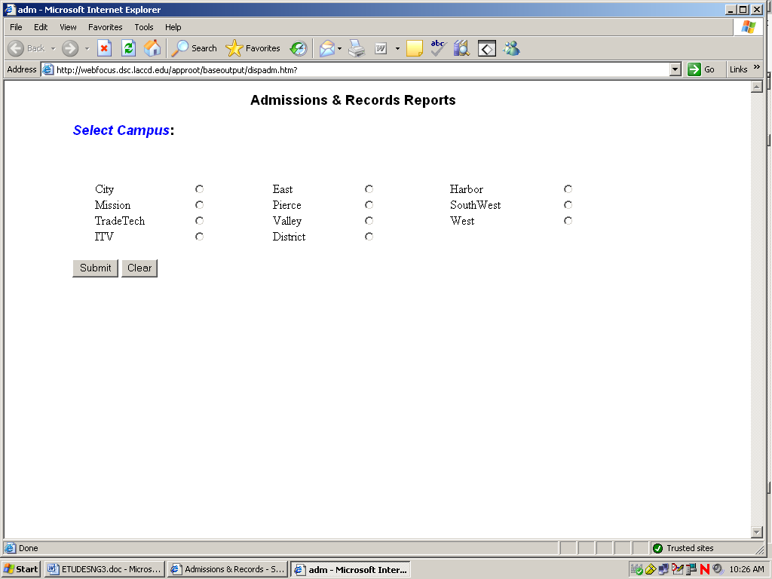

9 Click on the file name. DF9996_yys.CSV (where yy - 2-digit year, s - 1-digit term code as follows: 0 - Winter, 1 - Spring, 2 - Summer, 3 - Fall). to open the file.
eg: DF9996_072.CSV represents the SUMMER 2007 file.
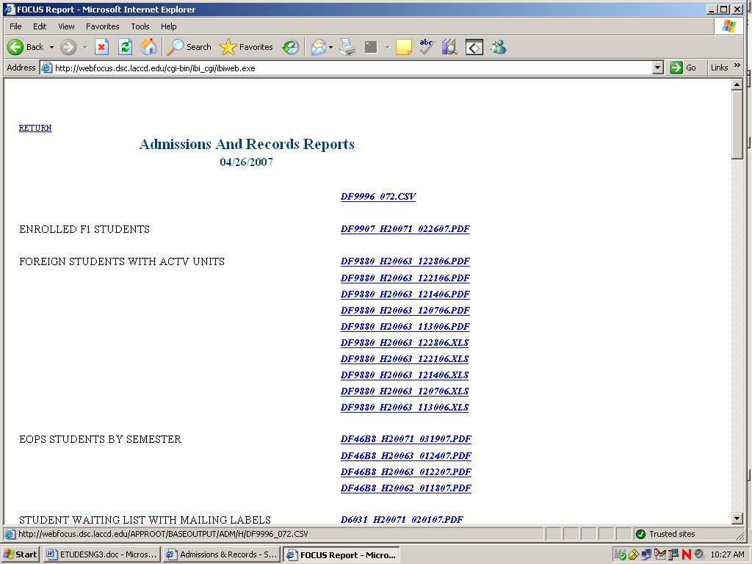

10. This file will have all the sections for the selected campus and term.
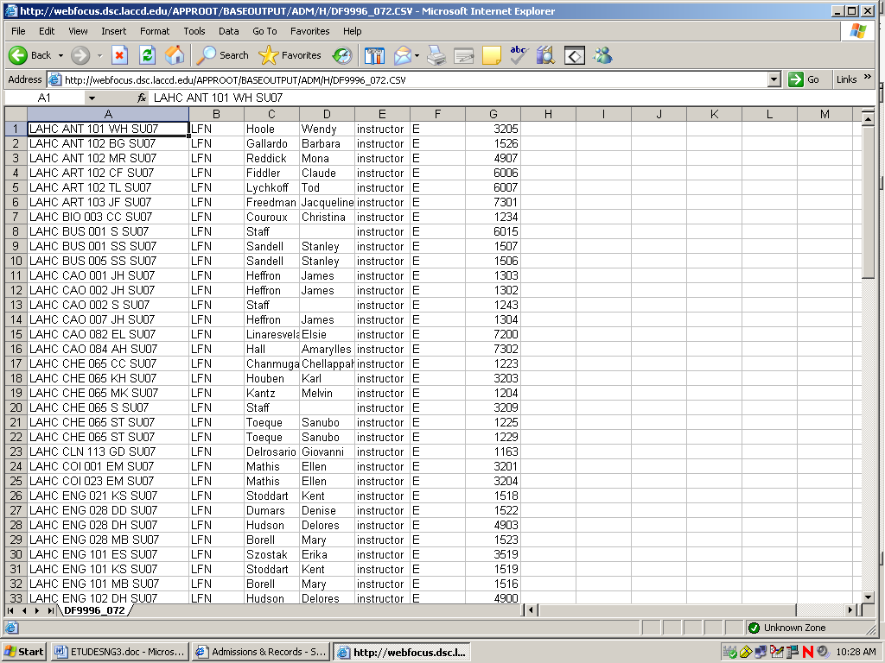

11. Open a new excel sheet and cut and paste the data lines for each section needed.

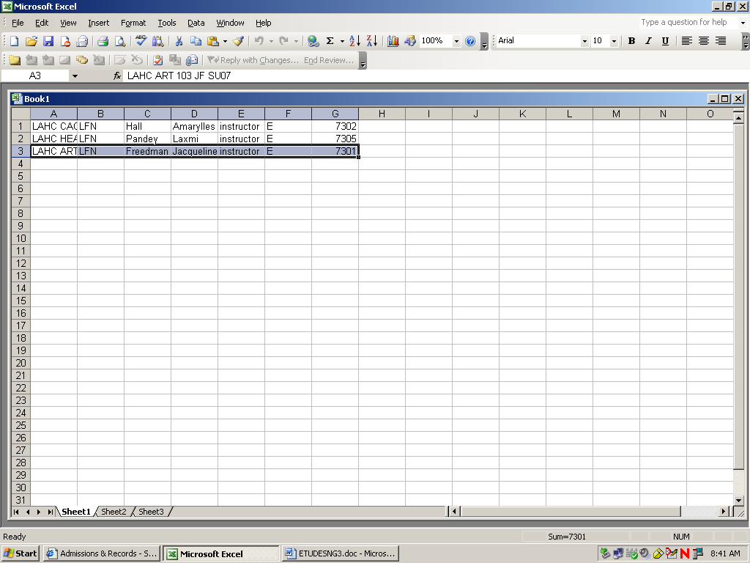

- Next, add columns for userid and email address:
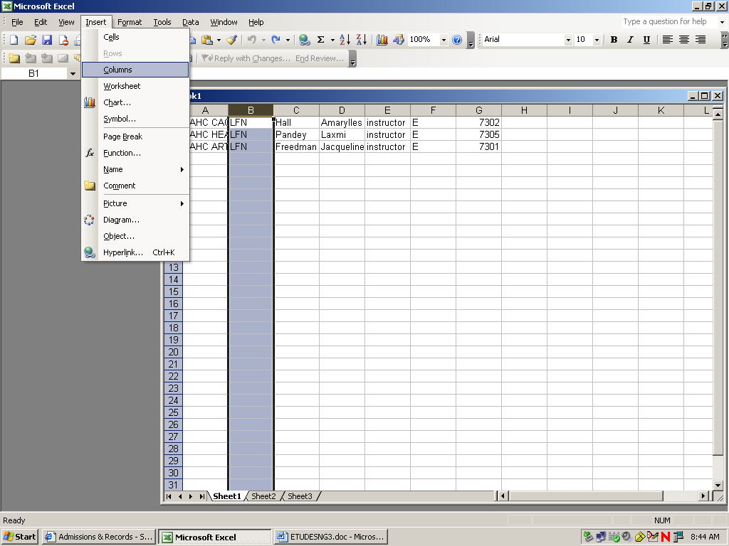

And:
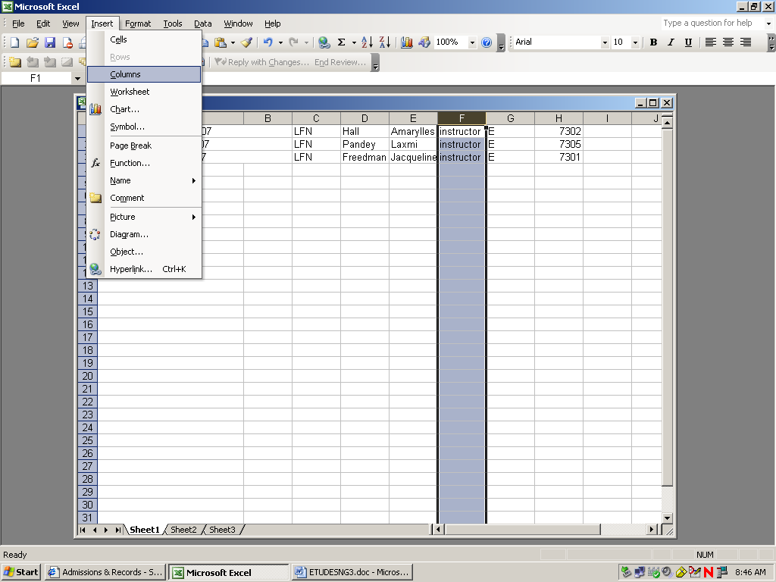

- Next, enter instructor userid and email address in the columns you created. This STEP is required for each course title
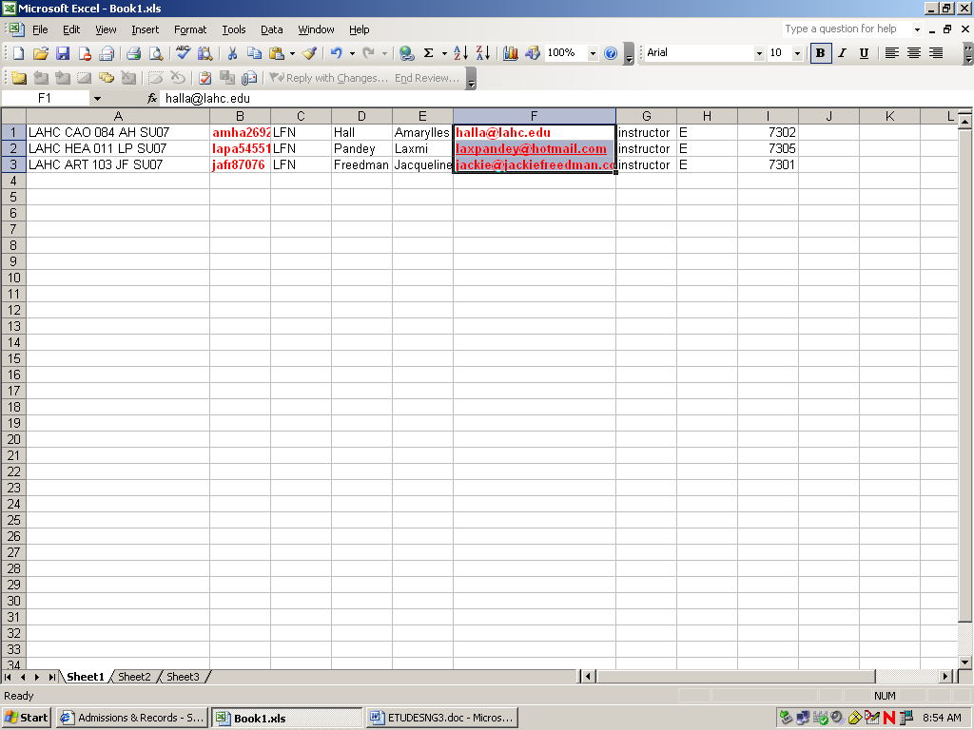

- Save this file as a .txt file:
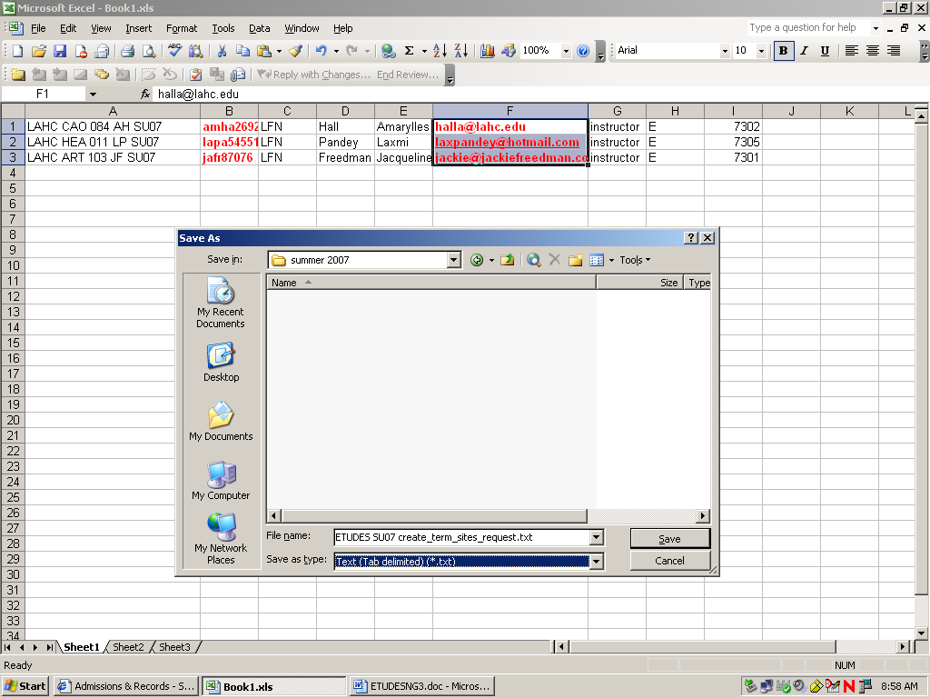

- Send file to Vivie Sinou [SinouVivie@foothill.edu].

NOTE: At the beginning of the semester when you create the initial file and build many sections for the first time, it is suggested that you copy the entire excel file to your desktop and delete sections lines that you do not need.

B. Create Student PASSER Parameter File:

Do not forget to send the student PASSER Parameter file of sections to District Data Control group required to create the student roster file.

To create the student roster file in the beginning of the Semester, do the following:
- Delete columns A through H:
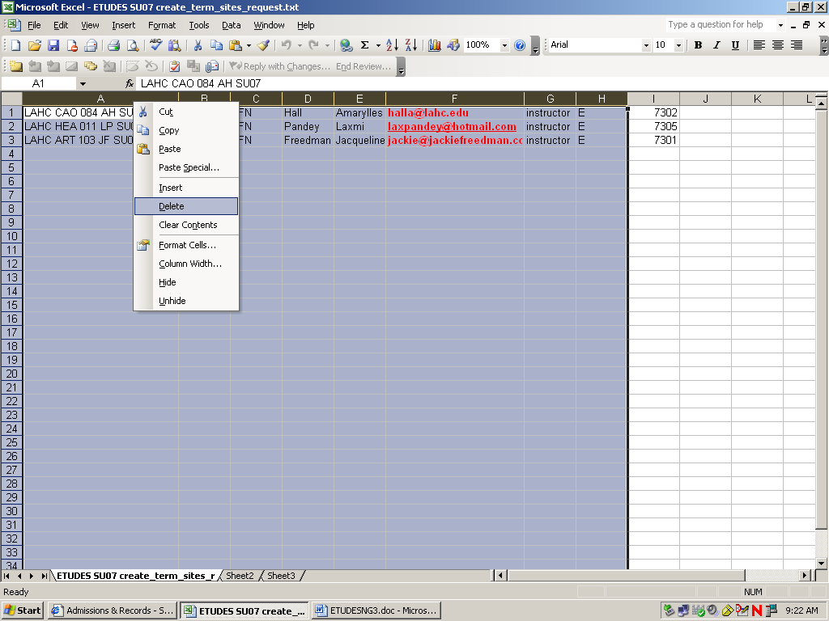

- Add your location (using Upper Case campus code) to the remaining column:
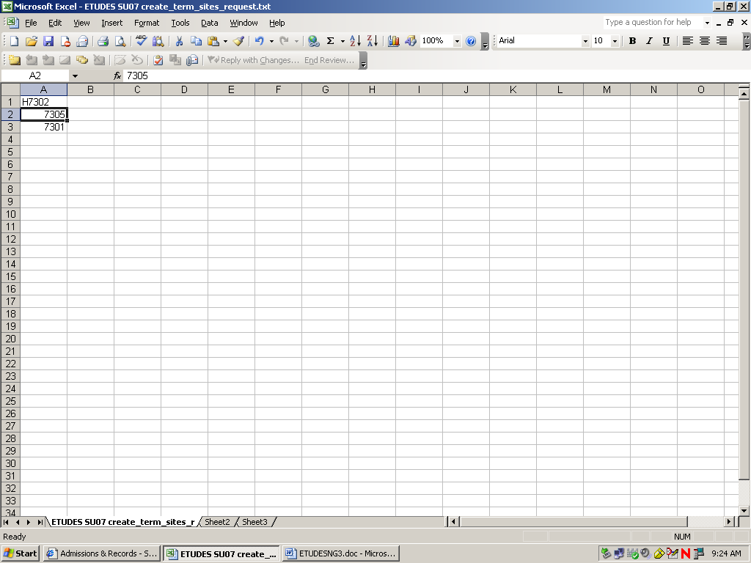

AND:
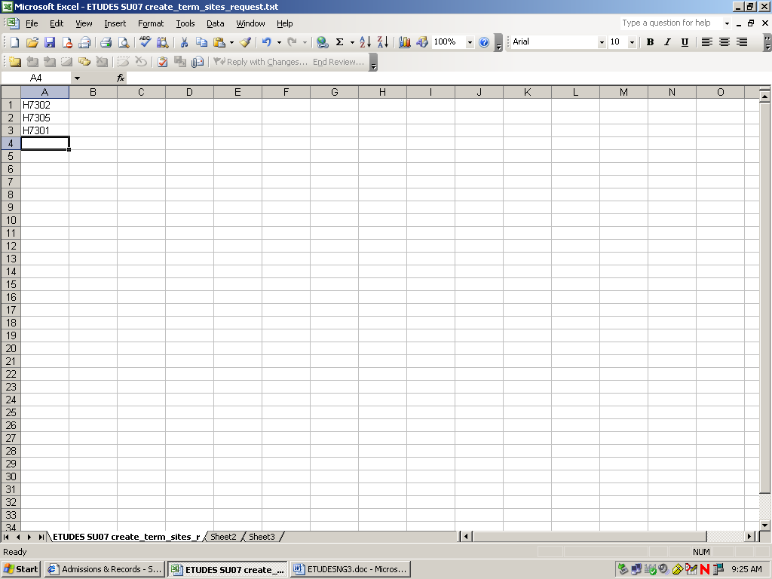

- Save the file as: student_parser.txt:
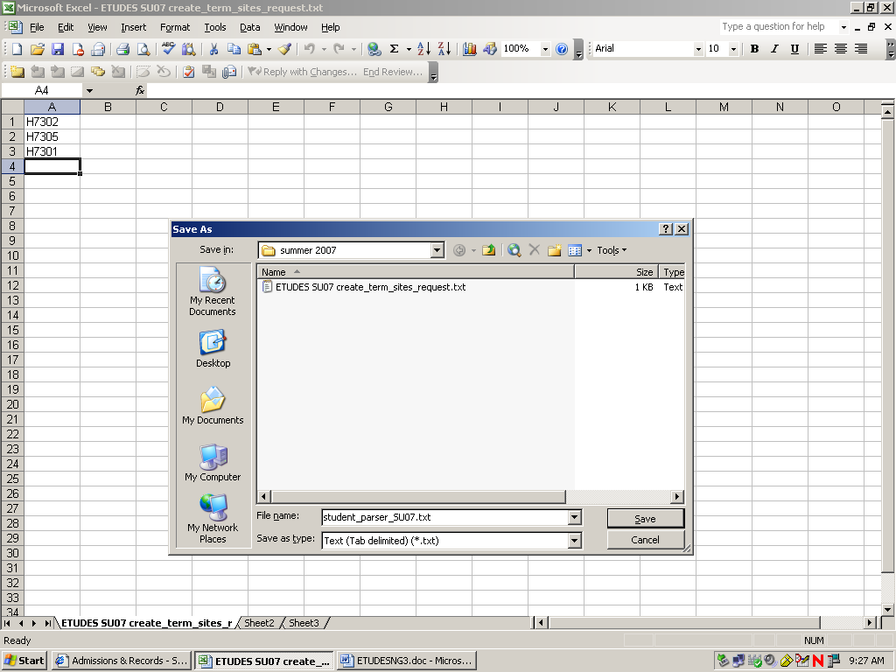

- Attach the file to an email and send it (with Campus code and options) by email to DATA CONTROL GROUP at Datacont@email.laccd.edu. Identify the College, Semester and Year in your email to to DATA CONTROL GROUP.

A few reminders:
D. If you need the section number in the course title
Ex: where section number 1217 is included in the course title
LAHC HIS 012 1217 SB SP07

type S next to the section.
H0200
H0201
H1217S
H3400
H8000
E. If you want to give a section a Course Title of another section
Ex: where H4070CESL 006A NS F06
type C to the right of the Section number 4070, followed by the course
title you request. This will designate
ESL 006A NS F06 without computing its own site title
H0200
H0201
H1217S
H3400
H4070CESL 006A NS F06
H8000

F. Save this completed parameter file and send this as an attachment with
your email .
G. Identify theCollege, Semester and Year in your email to to DATA
CONTROL GROUP and include a copy to Robert Richards.

Additional Options and Examples:

If you require other options, select to appropriate line and insert option..

Example 1;
If section number is to be included in course title, type section number in the title

ELAC ADM 188 ER 7035 SP07 | LFN | Rivero | Eddie | instructor | E | 7035

Next, add Userid and email address.

ELAC ADM 188 ER 7035 SP07 | Edri12345 | LFN | Rivero | Eddie | edri@gmail.com | instructor | E | 7035

Send that to Vivie Sinou [SinouVivie@foothill.edu].to create the site.

Example 2:
If you want to add section 7031 but want to designate ELAC ADM 152 KT SP07 for the section, then:

First, cut and past the data line for section 7031

ELAC ADM 188 ER SP07 | LFN | Rivero | Eddie | instructor | E | 7031

Second, identify the course title you want included into the file and cut and paste (or simply type) the course title from that line.

ELAC ADM 152 KT SP07 | LFN | Rivero | Eddie | instructor | E | 7031
Now section 7031 is designated with the Site title of the section 7070.

Now add Instructor's Userid and email address to this excel file

ELAC ADM 152 KT SP07 | Edri12345 | LFN | Rivero | Eddie | edri@gmail.com | instructor | E | 7035

Send to Vivie Sinou [SinouVivie@foothill.edu].

